EShop.com: Defect Report
Defect #1: Login page is not working.
Fixed: It is working fine now.

Defect#2: Create an account page is not working.
Fixed: It is working fine now.

Defect#3: T-Shirt page should not display Trousers. See the below given screen shot:
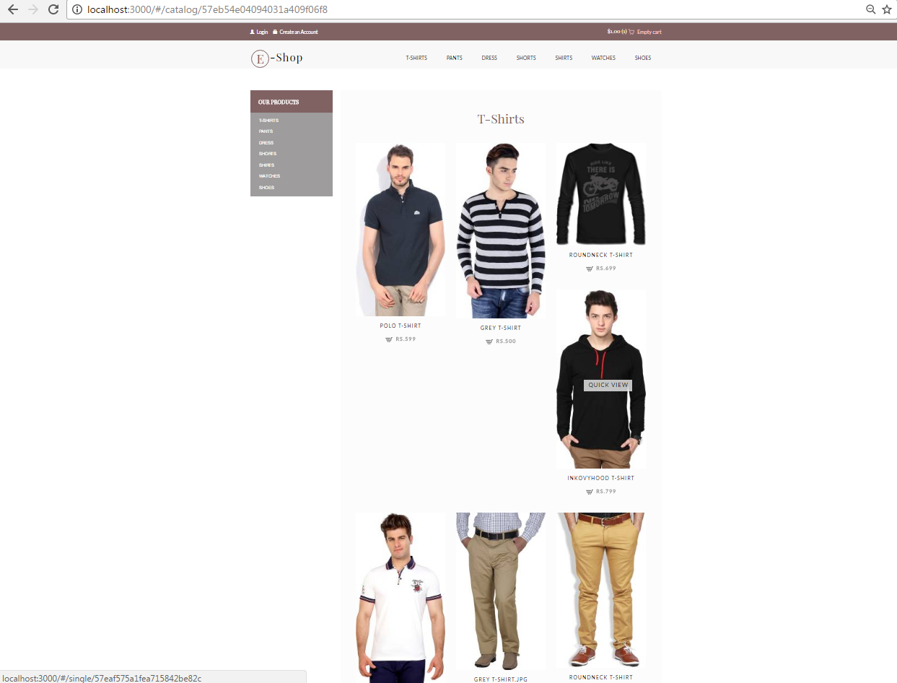
Fixed. It is working fine now, Trousers has been removed from the above said page. See the below given screen shot:

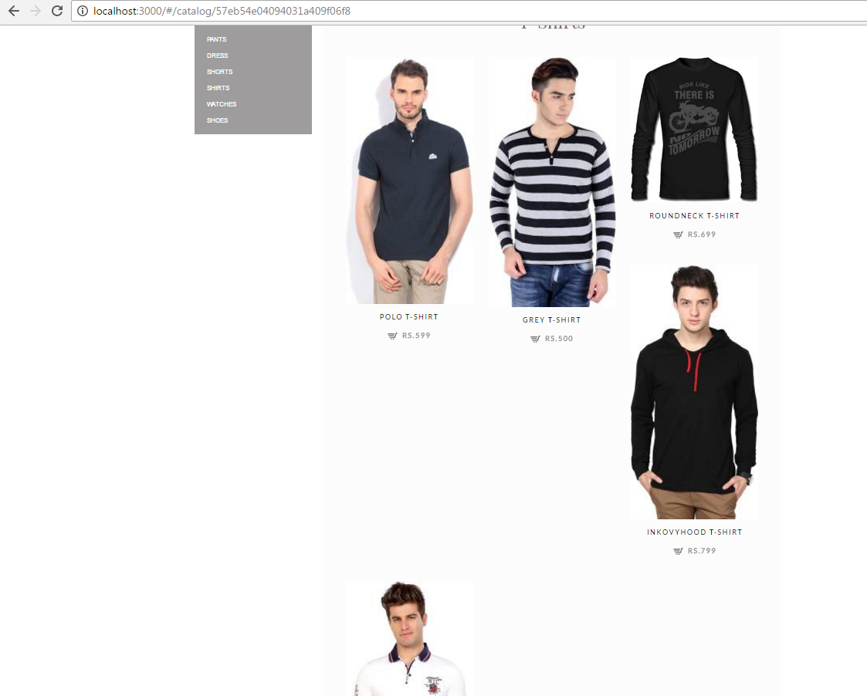

Defect#4: Pants page should have separate categories as Trousers & Jeans.
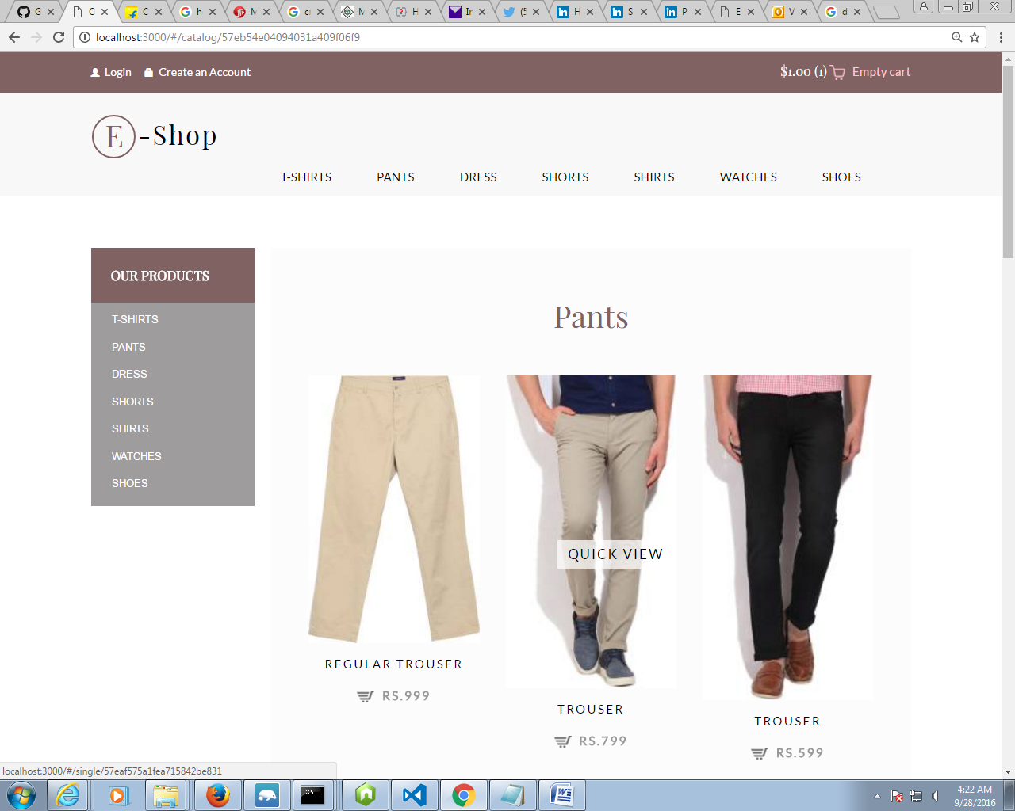

Fixed: Now we have separate categories as Trousers & Jeans.
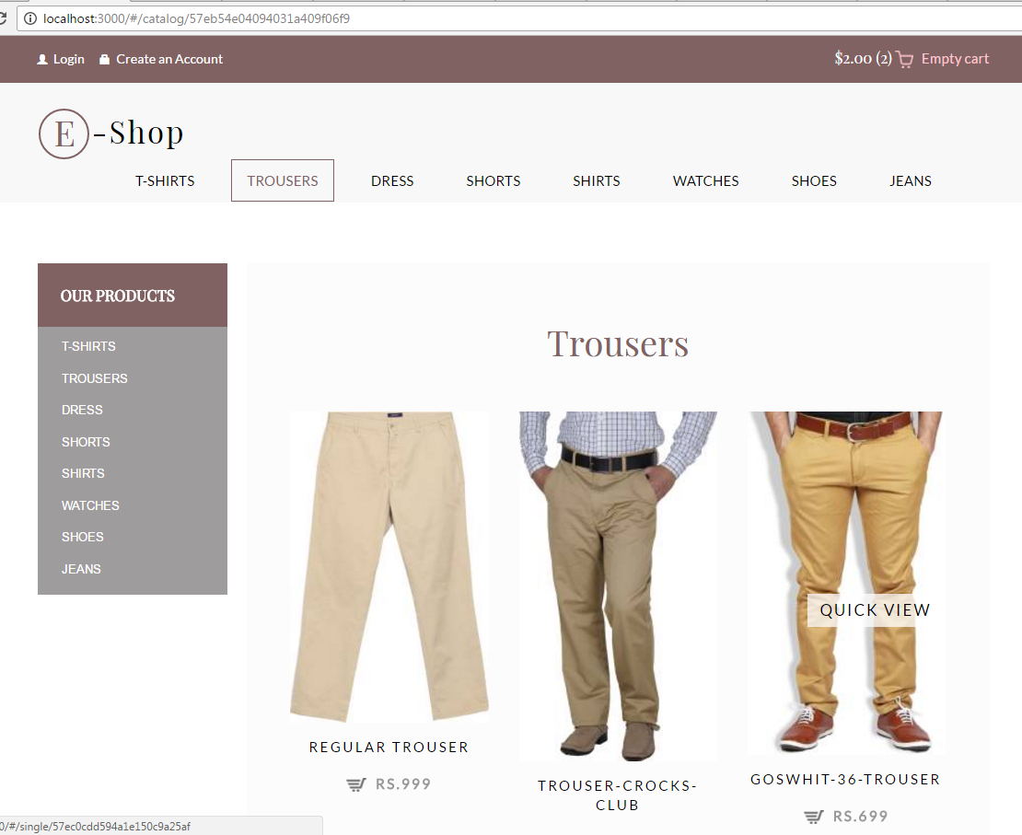

Defect#5: Shirts page should not have ladies dresses.
Fixed: Ladies dresses have been removed from the page now.
Defect#6: Watches should be aligned.
Fixed: Now it has been aligned.
Defect#7: Shoes should be aligned.
Fixed: Now it has been aligned.
Defect#8: Insufficient dresses under the dresses so more need to be added.
Fixed. We have added more dresses.

Defect#9: Shorts page should have shorts.
Fixed. We have added more shorts on the page.

Defect#10: Shorts should be aligned.
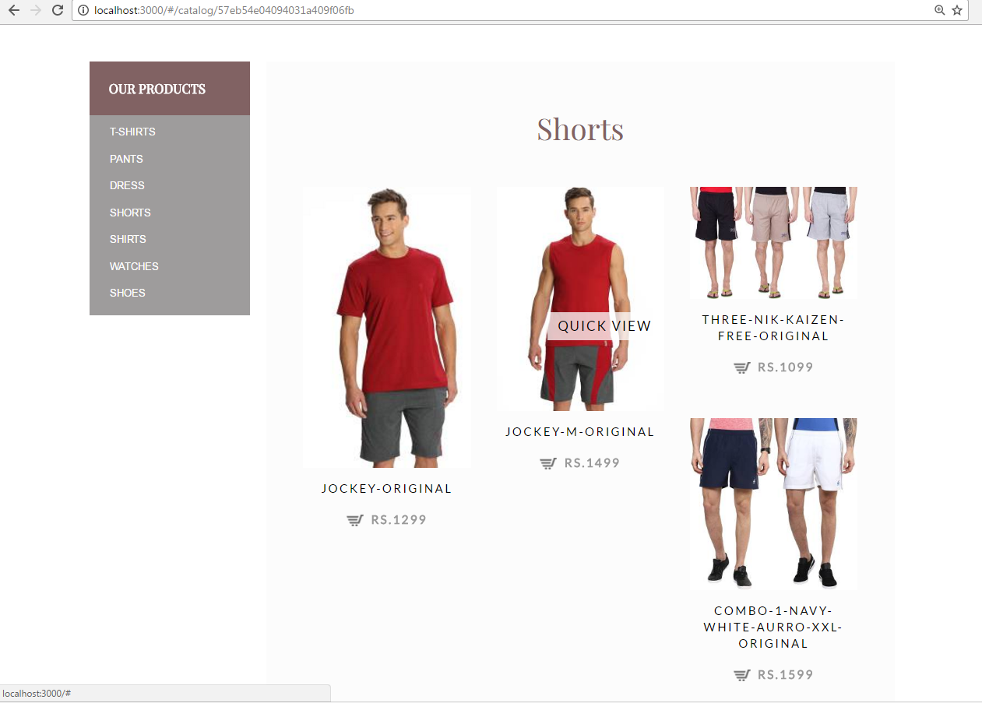
Fixed: Now it has been aligned.

